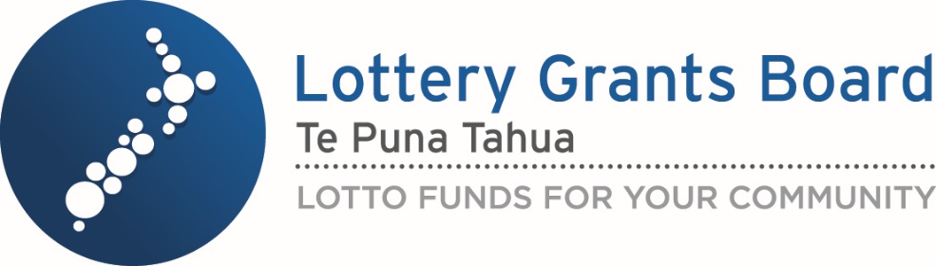

Lottery funding for equipment for people with a disability
Adapted in 2026 by Accessible Formats Service,
Blind Low Vision NZ, Auckland
Transcriber's Note: The logo at the top of the page is Lottery Grants Board — Te Puna Tahua. LOTTO FUNDS FOR YOUR COMMUNITY

Lottery funding for equipment for people with a disability
Lottery funding supports projects and activities that benefit New Zealand communities. The funding helps build strong and sustainable communities.
People with a permanent disability can apply for lottery funding to access equipment that enables meaningful participation in community life.
Community life includes taking part in social, cultural, recreational, community and volunteer activities.
This funding is for individual people with a permanent disability who are experiencing barriers to their participation in their community, that will be reduced by having this equipment.
Lottery funding is intended to supplement, not replace, funding available through government agencies and other primary funding sources.

Eligibility
You can apply if you:
- have a permanent disability
- are a New Zealand citizen or are a New Zealand permanent resident
- can show how the equipment will help you participate in community life
Funding is intended to support participation in community life and any personal benefit must be secondary to the community benefit.

Equipment we may fund
Disability related equipment that directly supports participation in community life. For example:
- mobility equipment: vehicles, vehicle modifications, wheelchairs and mobility scooters.
- communication aids that support participation in community life
- certified disability assist dogs.

What is not funded

Not eligible
- Temporary disabilities
- Accident Compensation Corporation (ACC) covered injuries

Equipment we do not fund
- Home alterations
- House equipment
- Equipment for education, employment or professional sport.

Costs we do not fund
- Vehicle registration
- Warrant of Fitness (WoF)
- Insurance

Supporting information to go with applications
You will need to provide the following supporting information with your application.

Equipment needs assessment
This assessment must be independent, current and relevant to the equipment being requested. This must be on the DIA Equipment for People with a Disability template at: https://bit.ly/4rxL7GI
The assessment will need to confirm:
- that the equipment is suitable
- the nature of disability
- that it is a permanent disability
- how your disability affects your daily life and participation in your community.

Vehicle and vehicle modifications
Applications for vehicles and vehicle modifications are a two-stage process.
Stage 1—Transport Assessment
You will need a specialist transport assessment from a specialist transport occupational therapist. You can either apply for lottery funding for the assessment or it can be self-funded. To apply for funding for the assessment, you will need to make an application and select Transport Assessment.
Stage 2—Vehicle or Vehicle Modification Application
When you have a transport assessment that confirms your requirements, you will need to apply for the recommended vehicle and/or vehicle modifications. Your application must be aligned with the assessment.
Receiving assessment funding does not guarantee equipment funding
Receiving funding for a specialist transport assessment does not guarantee that a further grant will be approved for a vehicle or vehicle modification. Any subsequent application will be assessed on its own merits and against the fund criteria.
What the assessment will confirm and consider
The assessment must confirm your disability-related need and the most appropriate transport solution. The assessment will also consider your mobility requirements, wider family circumstances, alternative transport options, vehicle modifications, and examples of suitable vehicles.

Community participation evidence
Evidence to show how the equipment will support your participation in community life, eg:
- a letter from a community organisation
- volunteer organisation confirmation
- information from a support service or health professional
- evidence of participation in social, recreational, civic or cultural activities.

Information about other funding
If you have applied for funding from other agencies for this equipment, we will need to see:
- evidence of other applications
- confirmation of eligibility or ineligibility
- evidence of co-funding arrangements
- evidence of proceeds from the sale or trade-in of existing equipment where applicable.

Equipment information
Two quotes must be supplied for each piece of equipment requested.
Quote requirements
All quotes must:
- be no more than 4 months old at the time of the submitting application
- clearly describe the equipment being provided
- match the equipment being applied for
- quotes must be obtained through a fair process. Any actual, potential, or perceived conflict of interest, including relationships between the supplier and applicant organisation, must be disclosed
- discretion may be used to reduce the number of quotes required where the equipment requirements limit the availability of suppliers.

Applying on someone else's behalf
If someone is applying on your behalf, they must provide evidence that they have authority to act for you (if applicable).

Important information
If your application is successful, we will pay the supplier directly.

How do I apply for funding?
If you are a returning applicant, then log in to the Grants Management System at: https://bit.ly/46CGXni
If you are a first-time applicant, we recommend calling us to talk to a Community Advisor before applying. Call us on 0800 824 824 or email community.matters@dia.govt.nz.
If you can't apply online, please complete a paper application form, click the following link to download the Equipment for People with a Disability application form at: https://bit.ly/4dyaxxZ
We recommend allowing up to a week to set yourself in the grants management system. To set up yourself up in the online grants management system, complete these steps.

1. Set up a RealMe login
- If you have an existing RealMe profile go to: "Step 2. Set up 2-Factor authentication".
- Follow the steps below to create a RealMe profile. You do not need a RealMe verified identity to access the grants management system.
- Set up a RealMe login account at: https://www.realme.govt.nz/
- Select "Create a RealMe login'
- Enter your details including a personal email address
- Do not share your login details with anyone under any circumstances.
- You will receive a confirmation email within 3 days confirming your RealMe profile has been set up.

2. Set up 2-Factor authentication
- 2-Factor authentication (2FA) is a security measure to keep your information safe.
- Follow the steps below to setup 2FA on your RealMe login:
- Log in to RealMe at: https://www.realme.govt.nz/
- Go to "Settings" tab at the top.
- Select the 2FA option that best suits you.
- For more help, watch the Setting up second factor authentication for the grants management system: a step-by-step guide using RealMe video guide at: https://bit.ly/4rt0lg3

3. Register in the grants management system
- Log in to the Grants Management System using your RealMe login. https://bit.ly/46CGXni
- Enter your name and contact details.
- Select submit request.
- We will email you confirmation of grants management system registration within 3 days.

4. Complete an online request form
- Log in to the Grants Management System using your RealMe login. https://bit.ly/46CGXni
- Select "create a request" to view a list of funds open for requests.
- Select the fund you want to apply to.
- Complete in the form. You can save your draft at any time by selecting "Save". Draft will appear in the sidebar under "Saved drafts". Click "edit" in the top left-hand corner to continue filling out your request.
- Upload any required supporting documentation in the request. You may not be able to submit the request if all required information is not provided.
- Check the organisation profile information is up to date.
- Select submit in the bottom left-hand corner.

When can I apply for funding?
There are four funding rounds per year. Applications can be saved as drafts and edited at any time during the year.
Applications can only be submitted and accepted during a funding round opening period.
The funding round dates are on the Community Matters website at: https://bit.ly/4dPk2J8

Contact options
To contact us, please use one of the following options:
- Email us at community.matters@dia.govt.nz
- Call us between 10am and 4pm on 0800 824 824
- If you are Deaf, hard of hearing, deafblind, speech impaired or find it hard to talk, you can use the New Zealand Relay Service. www.nzrelay.co.nz
More information is also available on the Community Matters website at: https://www.communitymatters.govt.nz/

End of Lottery funding for equipment for people with a disability

